Microstrip patch antenna (MPA)

**Objective:**

* To design and fabricate a linearly polarised rectangular/square microstrip patch antenna on a given FR-4 epoxy substrate of thickness 1.6 mm and dielectric constant 4.4 at a frequency of 2.4 GHz.
* To measure the antenna parameters like return loss, VSWR, radiation pattern (2D & 3D), and antenna gain.

**Theory**:

Microstrip patch antennas are a type of antenna where a metal patch mounted at a ground level with a di-electric material in-between. These types of antennas can be printed on PCB and the designs are very flexible. Here the thickness of ground plane or the patch is not important. These types of antenna operate at high frequencies.

The frequency of operation of antenna can be found using following equation

$$f_{c}= \frac{C}{2L\sqrt{ε_{r}}}$$

Putting all the values we will get 2.4 GHz.

Width of the patch can be found using the following equation

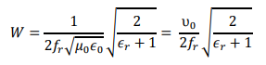

Effective dielectric constant



Length correction in the patch due to fringing effect

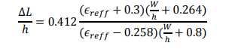

Effective length of patch will be



Feed point position or the inset length calculation

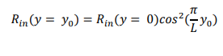

We know that Impedance when y= $y_{0}$ will be 50 ohm but we also have to calculate the impedance at the boundary of the patch. We can do it using the following equation

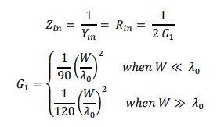

Some values which are given in the lab manual are:

|  |  |
| --- | --- |
| Resonant Frequency of patch antenna | 2.4 GHz |
| Relative permittivity of substrate | 4.4 |
| Thickness of substrate | 1.6 mm |
| Characteristics impedance of microstrip Transmission line | 50 ohm |

Using the above given data and putting these data in the MATLAB code given the lab manual, we got some of the required dimensions for making and simulating the patch antenna.

Some of the calculations we got using the given code in lab manual in the MATLAB software are:

|  |  |
| --- | --- |
| Length of the feed-line | 61.8 mm |
| $$Ɛ_{reff}$$ | 4.0857 |
| Width of the feed-line | 3.059 mm |
| Length of the patch | 29.422 mm |
| Width of patch | 38 mm |
| Inset length | 8.552 mm |
| Inset Width | 5 mm(chosen) |

I have taken the Substrate dimensions and also the ground plane dimensions using the concept of “From the edge of the patch add a quarter of a wavelength of extra dielectric”.

So, the patch width plus the length of a quarter of a wavelength added left, right and top of the patch. The length of the microstrip transmission line should be chosen so that the connection does not interfere the intrinsic pattern of your antenna.

λ = 125 mm

quarter wavelength = 31.25 mm

|  |  |
| --- | --- |
| Length (In x direction) | 113.92 mm (31.25 + 29.422-8.552+61.8) |
| Width (In y direction) | 100.5 mm (31.25+38+31.25) |

**Return loss** is the measure of how much power is reflected back in terms of input power through transmission line, optical fiber, etc. It is a measure of how well the device is matched.

**VSWR** is the measure of the how efficiently the power is transmitted into the load through the transmission line. It is calculated as the ratio of maximum voltage on the line to the minimum voltage on the line. It ranges from 1 to ∞.

**Radiation pattern** is the graphical representation of radiation properties of antenna as a function of space. It is the graphical representation of energy of the antenna.

**Gain** of antenna is the ability of the antenna to radiate compared to the ideal theoretical antenna.

**Design of the Patch Antenna:**

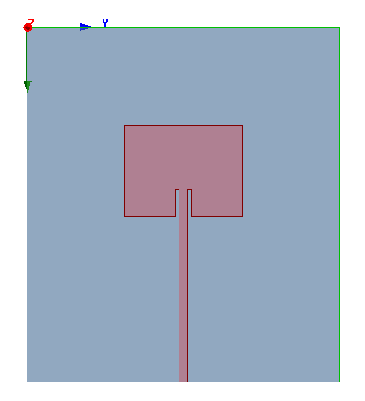 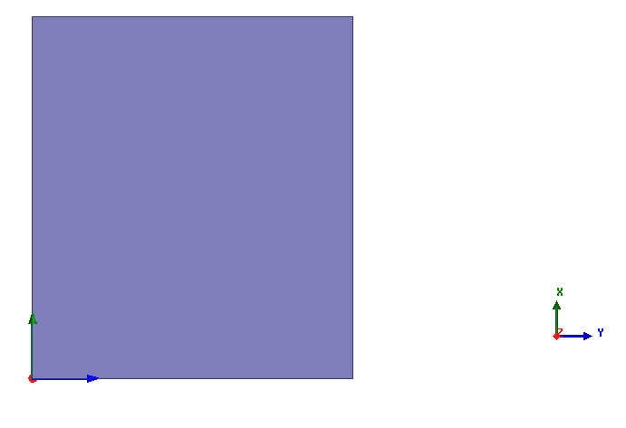 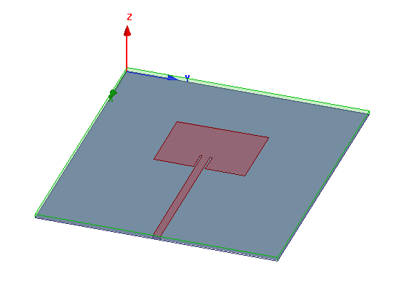

Fig. 1. Simulated antenna design; (a) Front view, (b) Back view with full ground plane, (c) Isometric view

**Results and Plots Obtained:**

**Return Loss plot**

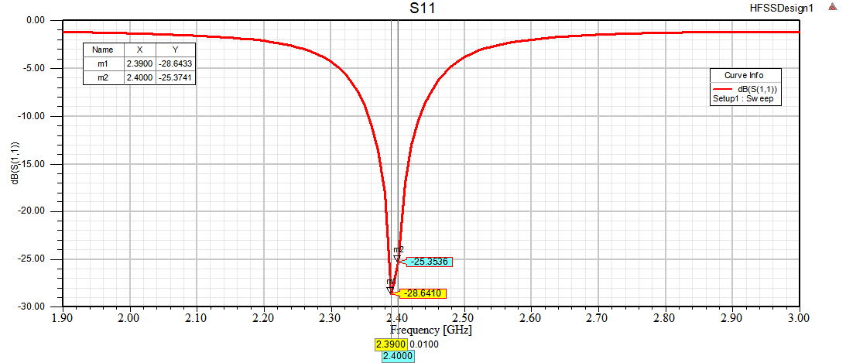

Fig. 2. Return loss versus frequency plot of the patch antenna

Here we can see that at 2.4 GHz resonant frequency we are getting -28 dB of the return loss while at the 20.39 GHz, we are getting return loss of -25 dB.

**VSWR plot**

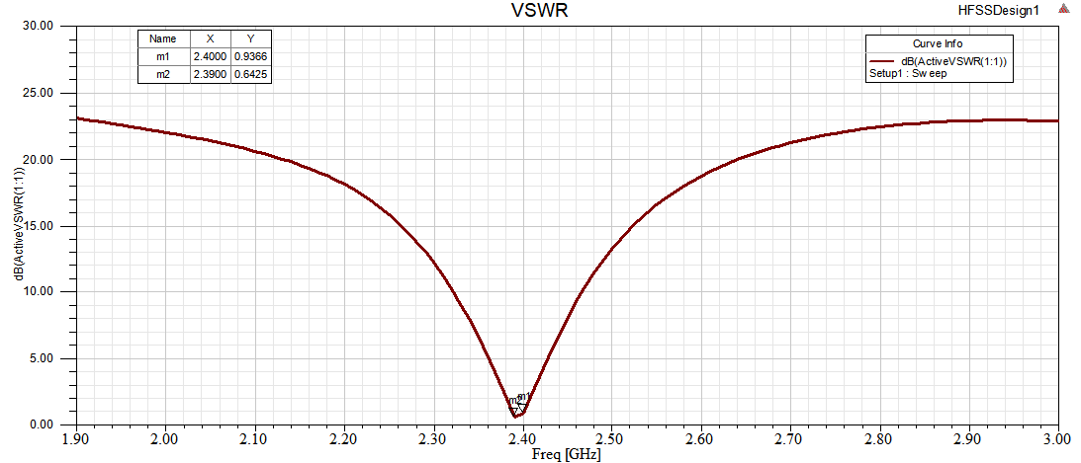

Fig. 3. VSWR versus frequency plot of the patch antenna

At the resonant frequency, we are getting the VSWR of 0.9366 while at the 2.39 GHz we are getting VSWR of 0.64.

**2D Radiation pattern (E field & H field)**

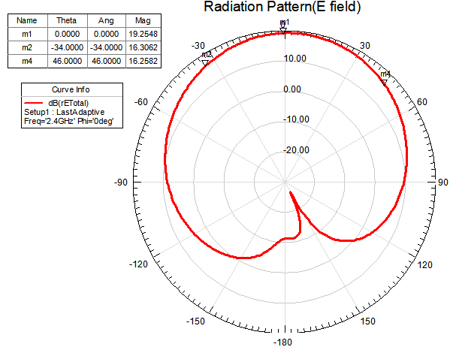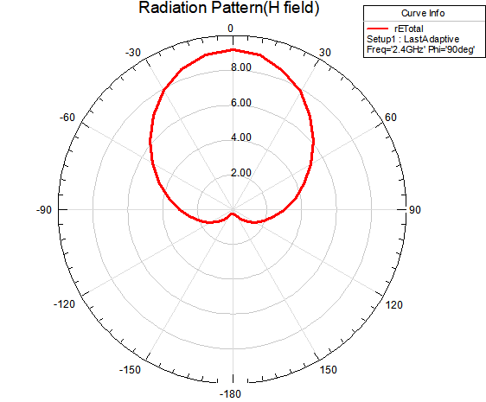

Fig. 4. 2D Radiation pattern; (a) E field radiation pattern, (b) H field radiation pattern

**3D radiation pattern**

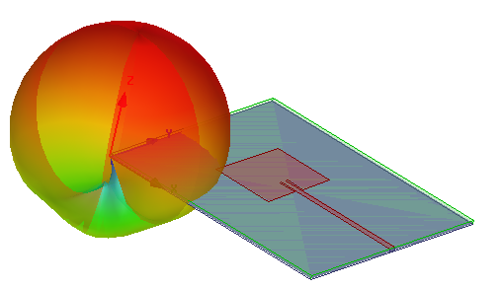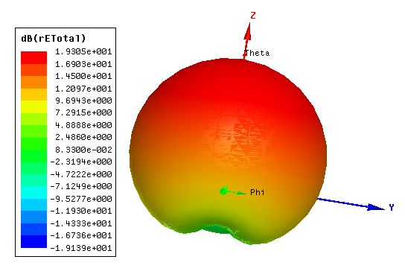

Fig. 5. 3D Radiation pattern; (a) 3D radiation pattern w.r.t diagram , (b) 3D field radiation pattern

**Gain**

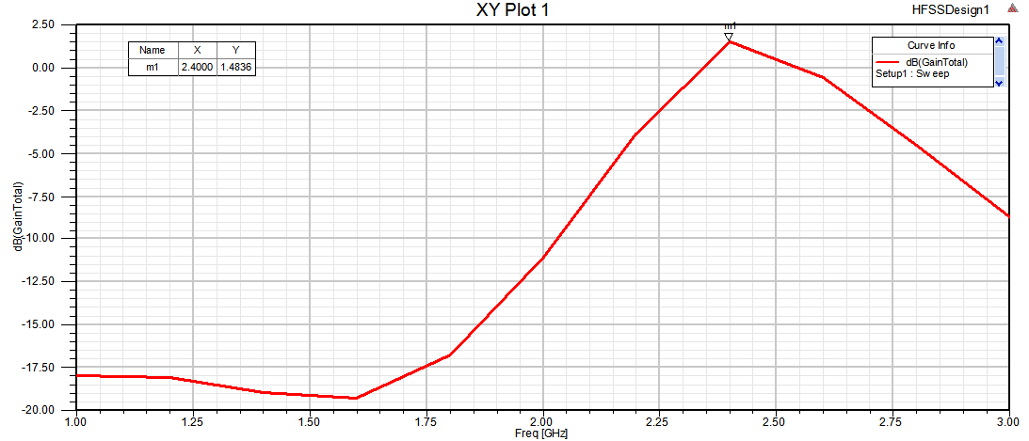

Fig. 6. Gain versus frequency plot of the patch antenna

We are getting a gain of 1.48 dB which is highest at the resonant frequency or 2.4GHz.

**Observations:**

It can be observed that the 3 dB radiation angle of the E field radiation pattern of the patch antenna is 34+45 = 79 degrees. So, the Half power beam-width will be 79 degrees.

**Conclusions:**

A design of rectangular microstrip patch antenna with microstrip transmission line feeding technique has been designed and simulated in the HFSS software. At the frequency of 2.4 GHz we are getting very good return loss of -25dB. It has a low gain of 1.48 dB at the 2.4GHz frequency. At the resonant frequency, the VSWR is nearly 1 which means we have nearly zero reflected power at the input node as the reflection coefficient is zero. Half power beam-width of this antenna is 79 degrees.